Test Scenario for the PITS#14113 – Mismatch in Clearing Type.

Test Setup

  - From the FirmProperties Window, set the Firm Trading Parameters as the following:

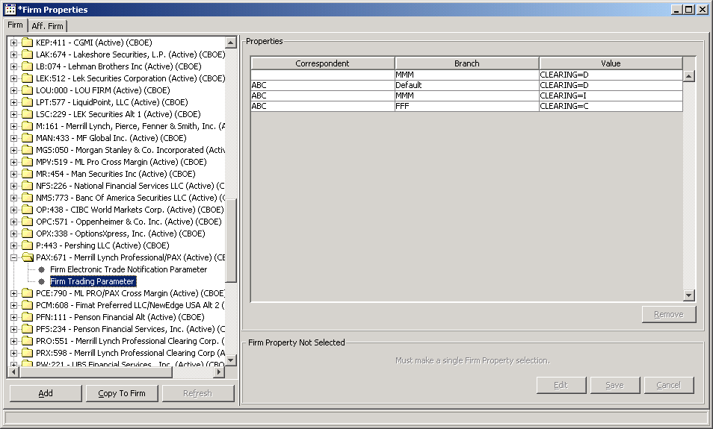

  - From the Trading Properties Window, set the following properties:

Set the Auction Enable as follows for your class:

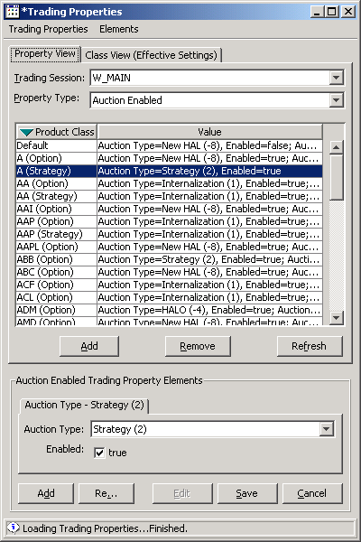

Set the Auction Minimum and Maximum Order Size as follows:

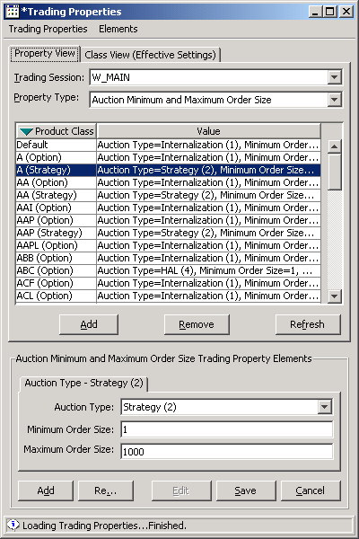

Set the Auction Time to Live as follows:

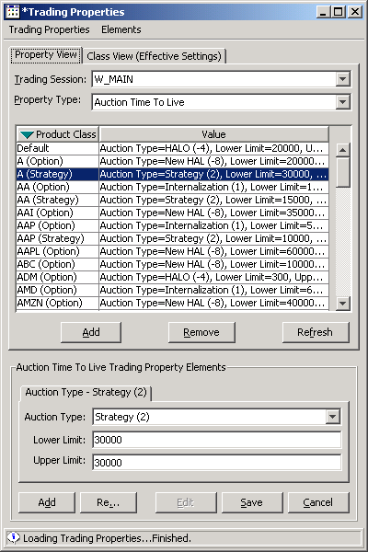

From Routing Properties Window, set the Firm Volume Limit Complex Order as follows:

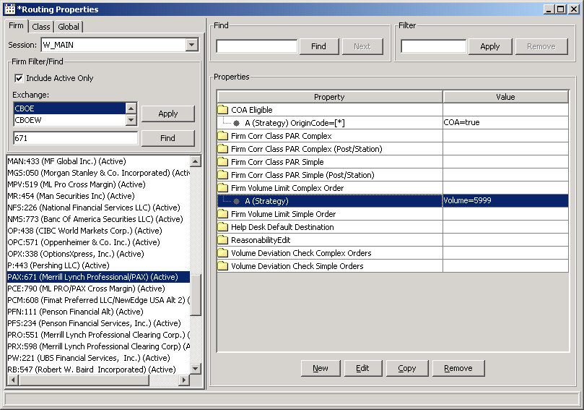

set the Volume Deviation Check Complex Orders as follows:

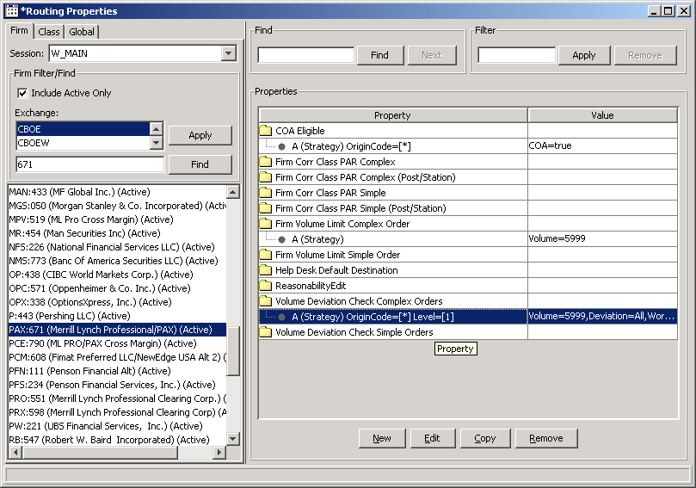
Test Case :

- Enter quotes on two option products (buy/sell) , 1.00 * 100 , 1.20 *100 on both legs (call and put).
- Create a new Spread Product with these two legs (one Call and one Put) with ratio: 1:1.
  - Enter a New AIM order, for the Primary order, same side: Market order, origin type: ‘M’, blank for the Sorrespondent ID and branch ‘MMM’ as follows:

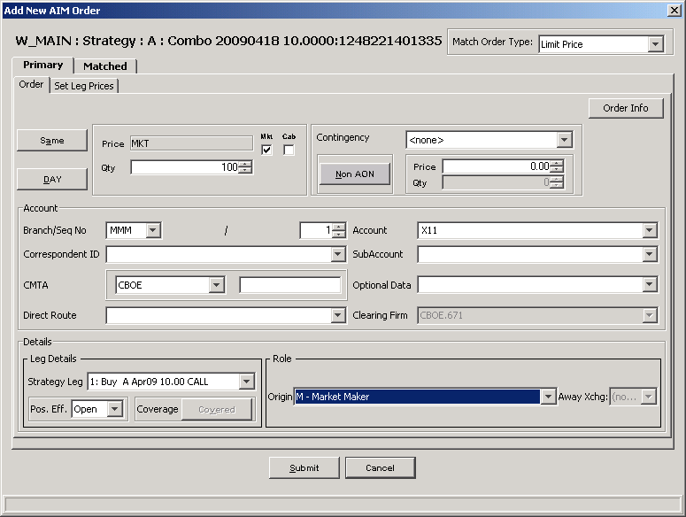

  - . Enter the Matched order, opposite side: 0.1 credit * 100, ‘C’ for the Origin, ‘ABC’ for the Correspondent ID, and ‘AAA’ for the Branch as follows:
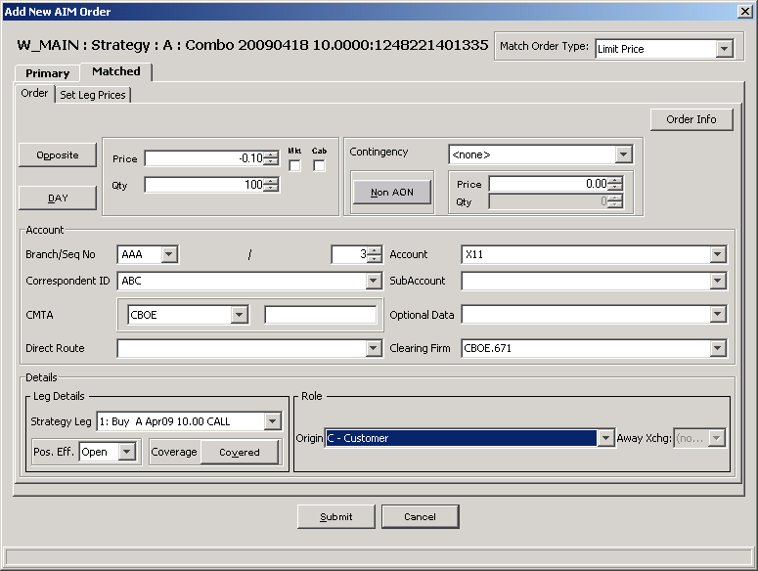

Verification:

Login to the BC in your enviroment and type loginDb W_MAIN, then enter the following query with your branch and branch sequence number:

select to_char(buyORDERID), buyer_clear_type,buy_ORSID, buyfirm,buyer, to_char(SELLORDERID),SELL_ORSID, seller_clear_type,sellfirm,seller
from sbt_tradereportentry t, sbtorder o
where ( t.buyORDERID = o.databaseidentifier or t.SELLORDERID = o.databaseidentifier)
and o.branch = 'PPP' and o.branchsequencenumber = 11;

The following is the query result, please verify the buyer_clear_type and seller_clearing_type are ‘D’.
TO_CHAR(BUYORDERID) B BUY_OR BUYFIRM BUYER TO_CHAR(SELLORDERID) SELL_O S SELLFIRM SELLER
---------------------------------------- - ------ ---------- ---------- ---------------------------------------- ------ - ---------- ----------
281037169436545 D 000030 671 XXA 281037169436548 000040 D 671 XXA
281037169436548 D 000040 671 XXA 281037169436545 000030 D 671 XXA
281037169436545 D 000030 671 XXA 281037169436548 000040 D 671 XXA

Test Scenario for the PITS#14008 – Order Routing Issue.

Test Setup

- Remove default Help desk OMT and Booth Default destination settings for your testing class.
- Set Session Class PAR to PAR1 (W901)
- Set Alternative of PAR1 to PAR2 (W902) and PAR3 (W903)
- Logout from PAR1 PAR2 and PAR3

Test Case :

BOTR: 1.05 - 1.15 100X100
Quote: 1 - 1.20 100X100
Enter Order; Sell 100 @ MKT
Auction Will start

Verification:

Result: After Auction Expires order will try to route PAR1. Since PAR1 is not logged in order will try to route PAR2 and PAR3. Though PAR2 and PAR3 also not available. Order should get routed to OHS with route reason: All attempts failed (6).

